Web Development – Mr. Turner

Smiley Face - CSS

**Project Overview**

Using CSS, you will manipulate some very simple HTML code to look like a face that blushes when you hover over it with the mouse. ***You may not change the HTML in any way (except to add classes if needed)!***

**Project Design**

This is Willie.

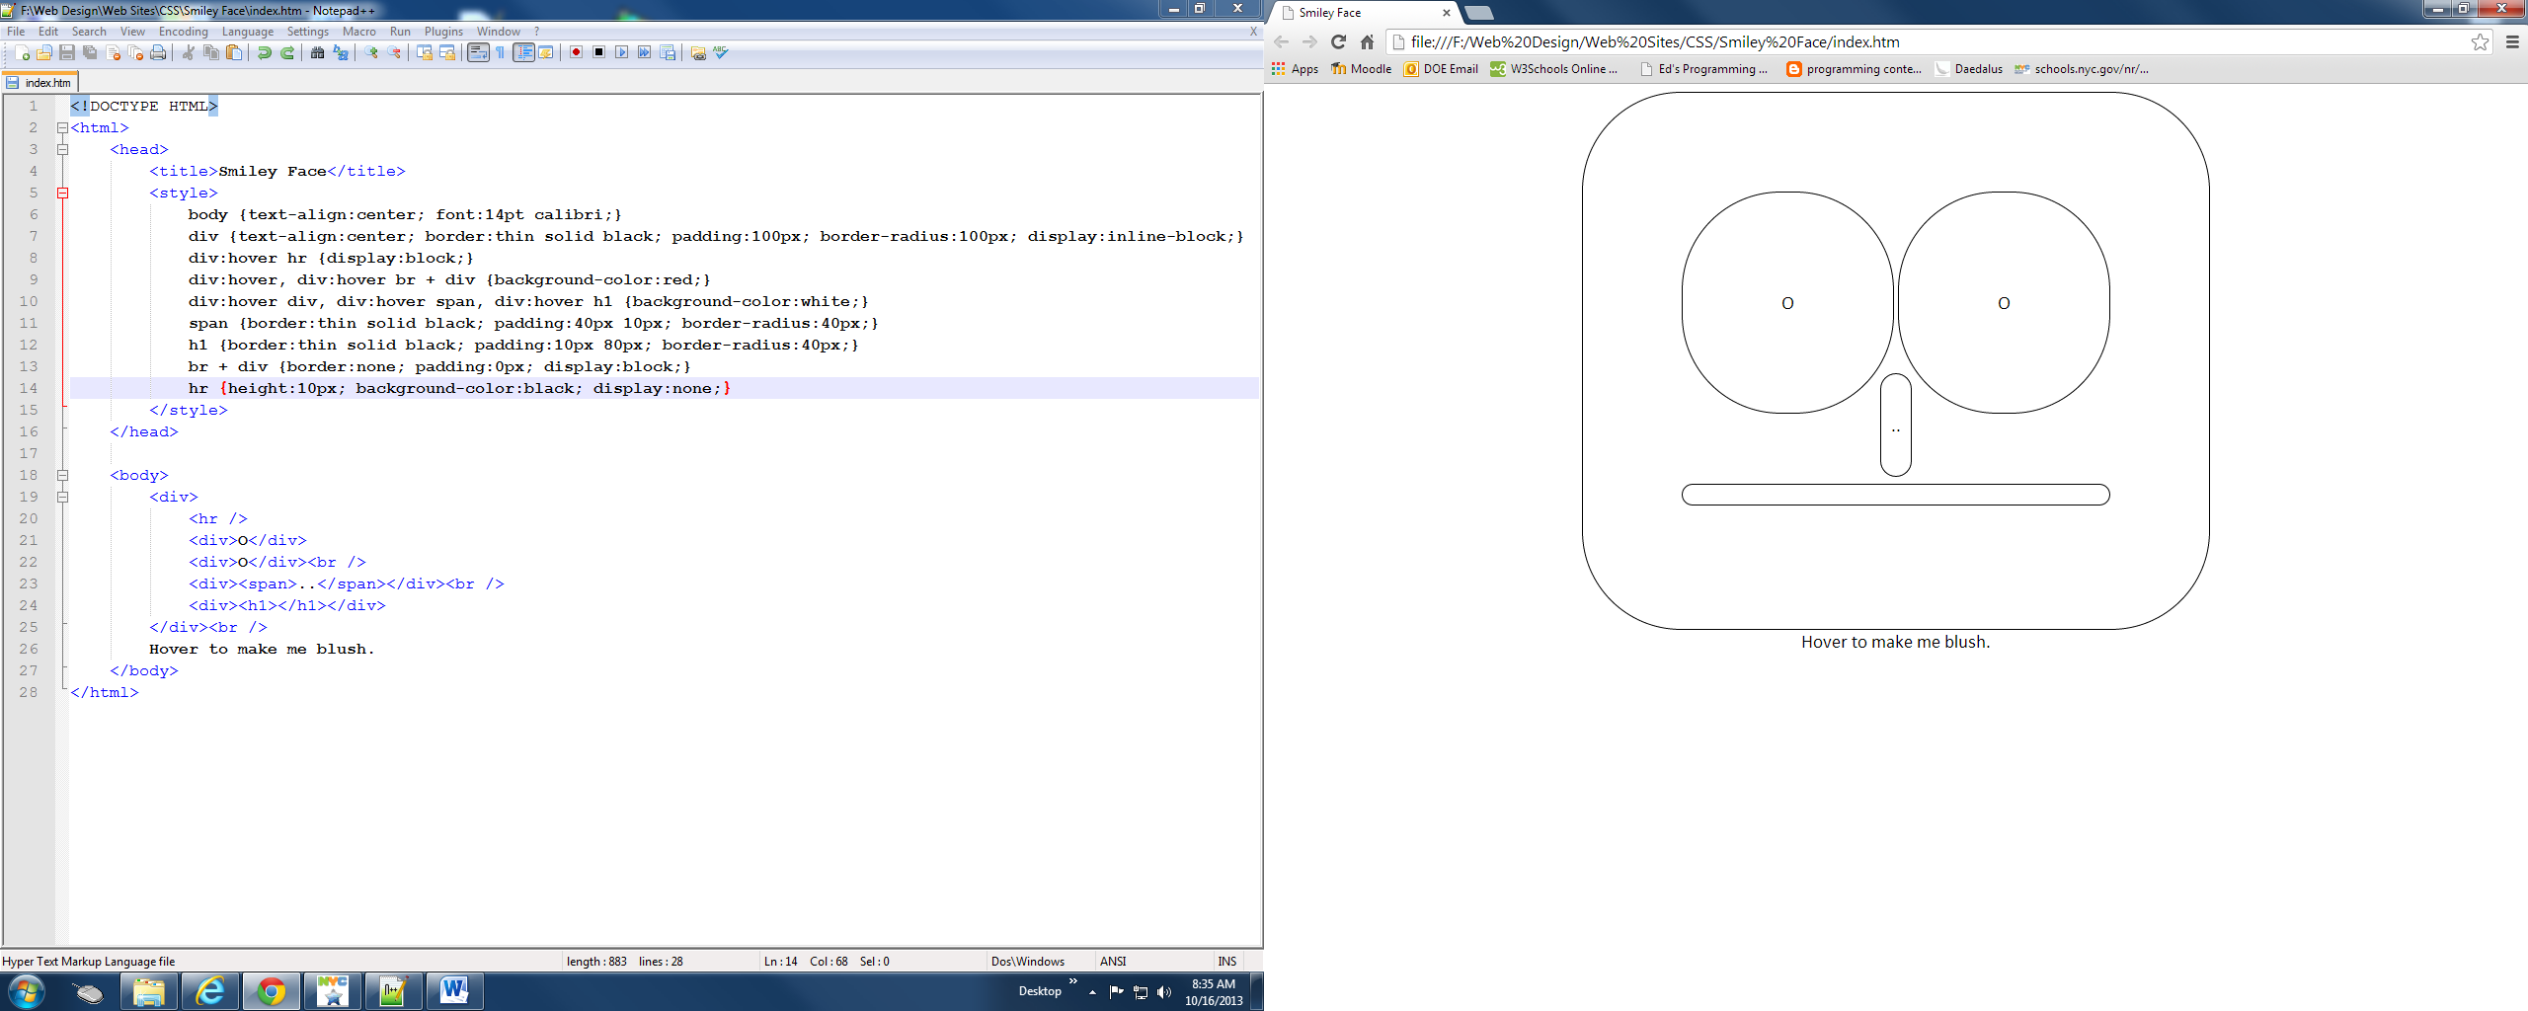

This is Willie when the mouse hovers over him (note the eyebrow).

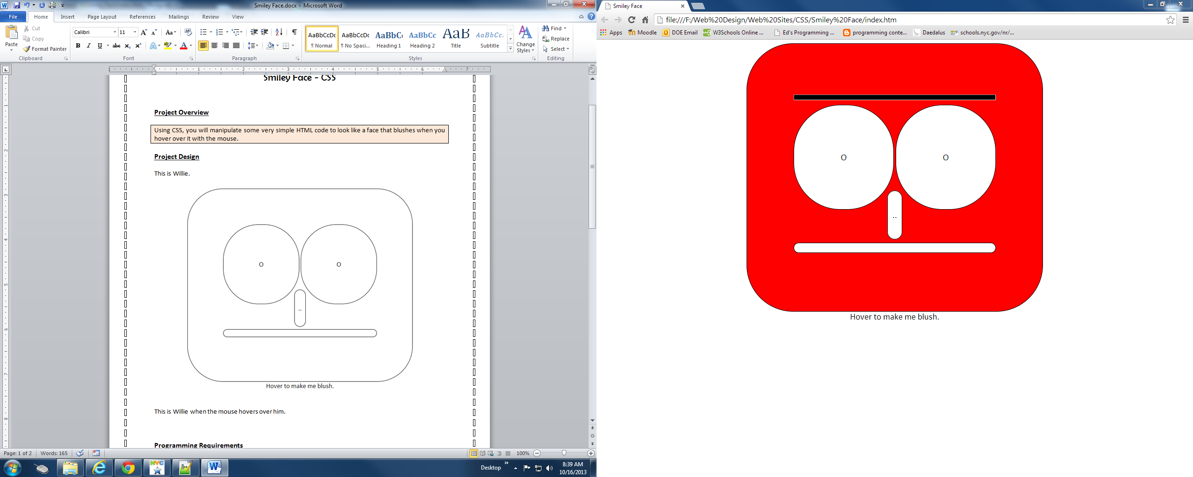

**Bonus**

***Program just one of these faces.***

Willie might look like this when the mouse hovers over him (if he’s surprised).

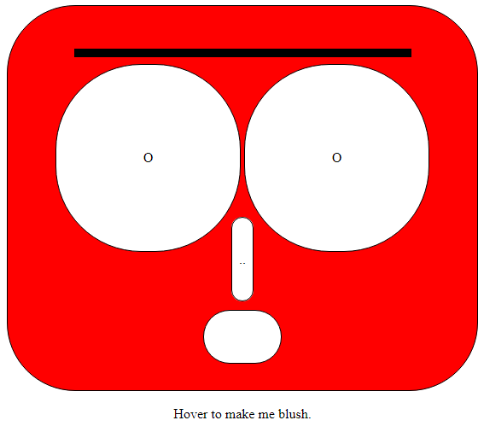

Or this (if he’s eye rolling).

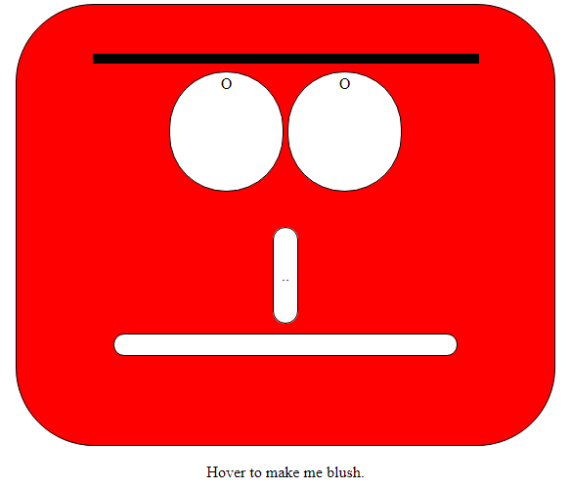

Or this (if he’s suspicious).

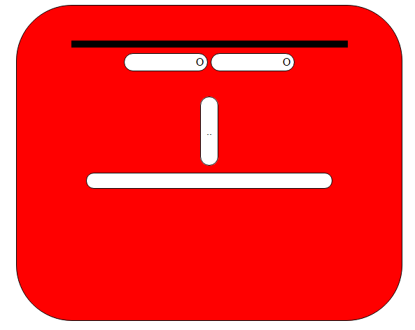

**Programming Requirements**

|  |
| --- |
| * You must code your own HTML. Use of a drag and drop interface or the usage of code downloaded from the internet is not permitted. |
| * Use of deprecated code is not permitted. Use the HTML 5 reference on [www.w3schools.com](http://www.w3schools.com) as your guide. |
| * Your page must be named *your full name index.html*. |
| * You must comment your name into the top of every page. |
| * Your code must be structured in a consistent and legible manner |
| * Your page may include well placed images. |
| * Your page must be formatted using CSS. |

**Submission**

Please submit only your html file, named *Your Name Willie.html*.